Genetic Basis of Gestational Diabetes in South-East Asian Women
Kyle Share and Professor Kinkhabwala
Department of Biology, Occidental College, Los Angeles, CA

Introduction and Background
Gestational diabetes (GDM) is one of the most common pregnancy complications affecting, on average, 14 of every 100 pregnancies worldwide. GDM arises from the normal interaction between placental hormones and insulin, where the mother’s body undergoes several physiological changes to supply the fetus with a continuous and adequate supply of glucose. Yet, when the mother’s body fails to compensate for naturally increasing insulin resistance, their blood sugars will rise, leading to GDM. This may cause macrosomia, premature birth, hypoglycemia, and obesity or Type 2 Diabetes (T2D) later in life for the fetus. Given these consequences, understanding the causes of and developing treatments for GDM are of critical importance, particularly in North Africa and South-East Asia which feature the highest levels of GDM at 27.6% and 20.8% respectively. Still, a precise and complete molecular explanation for GDM’s development remains elusive due to the sheer complexity of pregnancy and the number of physiological changes to the mother’s body. Thus, researchers employ specific computational biology techniques which offer the unparalleled ability to examine significant markers of GDM within the genome. By performing a Genome-Wide Association Study (GWAS), researchers can identify single nucleotide polymorphisms (SNPs) which statistically link genomic alleles to the presence of GDM.

Results
To test for GDM in pregnant mothers, doctors will perform an oral glucose tolerance test (OGTT) and analyze their blood sugars after two hours. Healthy mothers can metabolize high glucose levels relatively quickly whereas those with GDM will retain high blood glucose levels for several hours before falling back to baseline levels. To discover the genetic basis for GDM, researchers linked these results to each mother’s genome taken from non-invasive prenatal test sequencing data. Using this data, we constructed a Manhattan plot (Figure 1) which demonstrates the most significant shared SNPs between mothers with GDM compared to the baseline population. Each SNP was plotted according to their sequential 3’ to 5’ base pair location on the x-axis and the -log₁₀(p-value) on the y-axis. The resulting Figure 1 illustrates the mutations most closely associated with GDM. Although these entries denote the most statistically significant mutations to GDM, these results potentially obscure SNPs with slightly lower p-values yet feature large beta values — the degree to which a given SNP affects the severity of GDM. Thus, for all chromosomes with significant SNPs, we plotted the largest three Reference SNP cluster IDs (rsIDs) with the largest beta values for each chromosome as reflected by the annotations in Figure 1.

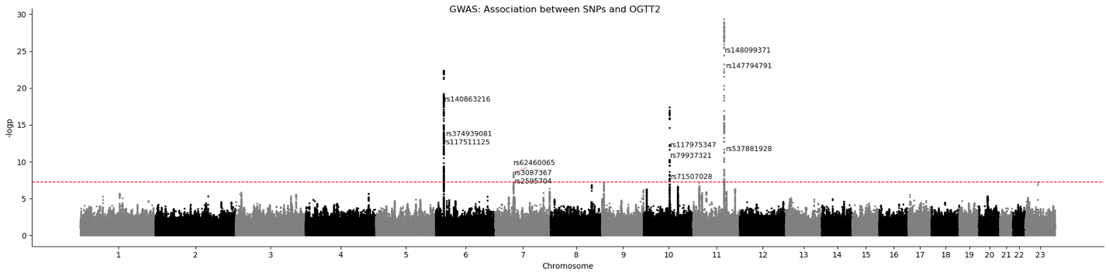
Figure 1: Oral Glucose Tolerance Test 2-Hour Manhattan Plot. Baseline and 2-hour blood glucose levels were measured for all participants following ingestion of 75 grams of glucose. Data was analyzed according to the phenotypic definition of GDM for OGTT

All twelve annotated variants from Figure 1 were then fed into the biothings_client Python package to determine the gene of each variant and the mutation type. Zero of the twelve identified SNPs existed in the coding region of a gene. This result, therefore, inhibited further AlphaFold studies of the mutations’ effects on protein structure.

Table 1: Gene Identification and Mutation Type for Significant SNPs. Annotated genes from Manhattan plot were analyzed in the biothings_client Python package. Variant genes and mutation types were produced as a pandas data frame.
Significant Variation Identification
 | rs_id | gene | mutation_type
1 | rs537881928 | MTNR1B | intergenic/unknown
2 | rs148099371 | LOC105369431-MTNR1B | intergenic/unknown
3 | rs140863216 | CDKAL1 | intergenic/unknown
4 | rs147794791 | LOC105369431-MTNR1B | intergenic/unknown
5 | rs374939081 | CDKAL1 | intergenic/unknown
6 | rs117511125 | CDKAL1 | intergenic/unknown
7 | rs117975347 | LOC101928994 | intergenic/unknown
8 | rs79937321 | LOC101928994 | intergenic/unknown
9 | rs71507028 | LOC101928994 | intergenic/unknown
10 | rs2595704 | AEBP1 | intergenic/unknown
11 | rs62460065 | MIR4649 | intergenic/unknown
12 | rs3087367 | AEBP1 | intergenic/unknown
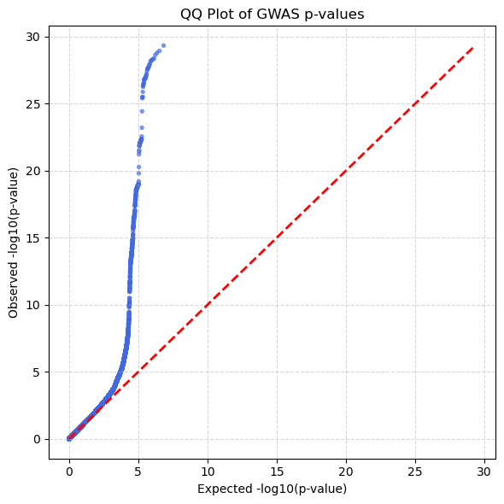
Nevertheless, as a third computational method to verify the Manhattan plot results, the p-value of each significant SNP and a representative sample of insignificant SNPs were plotted in a QQ-plot in Figure 2. Although Figure 1 identifies which SNPs are significant and Table 1 provides information on which genes these variants are located, Figure 2 identifies whether any systemic bias exists in the dataset that would nullify the results by amplifying or silencing other potentially significant genes. To quantify the bias present in the dataset, we found the Genomic Inflation Factor λ to be 1.0493 representing minimal evidence of systemic bias.
Figure 2: QQ-Plot of OGTT2 Study. Negative log10 p-values for each SNP were plotted against a normal distribution of values provided the null hypothesis is true. Results demonstrate strong verifiability with a lambda score of 1.0493.

Discussion
The results presented in this OGTT2 study are revealing yet inconclusive. While the data identifies SNPs that are not widely reported in the NIH dbSNP index, none of these SNPs exist within coding regions of the genes. Therefore, a simple conclusion between missense variations and GDM cannot be drawn. Nevertheless, it is entirely possible that some of these variants, such as rs148099371 (beta = 6.905860) exist in a promoter region of the gene that can exaggerate or inhibit expression levels. Additionally, while the data presented in this research demonstrates the OGTT2 study, it’s possible that waiting two hours after glucose ingestion masks many individuals who have GDM but can reasonably lower their blood glucose levels by the second measurement. For this reason, future studies should aim to identify data at the 1-hour mark and observe whether any missense SNPs can be observed. Regardless, this study demonstrates the complexity that remains around characterizing GDM. Although GWAS does not reveal a direct answer or a single protein responsible for the phenomenon, these results give clues as to how LOC105369431, MTNR1B, and CDKAL1 may be involved in the development of this disease. Moreover, although research is required to understand the exact molecular mechanisms behind GDM, current treatments—such as insulin injections—are provenly safe and effective for most women. As researchers continue to identify genetic and molecular bases explanations, GDM, though widespread, remains treatable and does not entirely prevent mothers from giving birth to healthy children.

Bibliography
- American Diabetes Association. How will this impact my baby? https://diabetes.org/living-with-diabetes/pregnancy/gestational-diabetes/how-will-this-impact-my-baby
- Calvo, M. J., Parra, H., Santeliz, R., Bautista, J., Luzardo, E., Villasmil, N., Martínez, M. S., Chacín, M., Cano, C., Checa-Ros, A., D'Marco, L., Bermúdez, V., & De Sanctis, J. B. (2024). The placental role in gestational diabetes mellitus: A molecular perspective. touchREVIEWS in Endocrinology, 20(1), 5. https://doi.org/10.17925/EE.2024.20.1.5
- Mayo Clinic Staff. (2025, May 30). Gestational diabetes - Diagnosis & treatment. Mayo Clinic. https://www.mayoclinic.org/diseases-conditions/gestational-diabetes/diagnosis-treatment/drc-20355345
- Wang, H., Li, N., Chivese, T., Werfalli, M., Sun, H., Yuen, L., Hoegfeldt, C. A., Powe, C. E., Immanuel, J., Karuranga, S., Divakar, H., Levitt, N. S., Li, C., Simmons, D., & Ji, L. (2022). IDF Diabetes Atlas: Global estimates of prevalence of gestational diabetes mellitus for 2021. Diabetes Research and Clinical Practice, 183, 109050. https://doi.org/10.1016/j.diabres.2021.109050
- *Zhen, J., Gu, Y., Wang, P., Wang, W., Bian, S., Huang, S., Liang, H., Huang, M., Yu, Y., Chen, Q., Jiang, G., Qiu, X., Xiong, L., & Liu, S. (2024). Genome-wide association and Mendelian randomisation analysis among 30,699 Chinese pregnant women identifies novel genetic and molecular risk factors for gestational diabetes and glycaemic traits. Diabetologia, 67(5), 844–857. https://doi.org/10.1007/s00125-023-06065-5

AI Usage

AI was not used in the writing of nor research for any part of this paper. AI was only used in the guidance for and generation of a portion of code in the Jupyter Notebook.

Acknowledgements
We are grateful to Professor Kinkhabwala for her oversight in this research. This study was supported by the Biology department at Occidental College.

H. Wang et al., "IDF Diabetes Atlas: Global estimates of prevalence of gestational diabetes mellitus for 2021," Diabetes Research and Clinical Practice 183 (2022): 109050.
M. J. Calvo et al., "The placental role in gestational diabetes mellitus: A molecular perspective," touchREVIEWS in Endocrinology 20, no. 1 (2024): 5.
American Diabetes Association, "How will this impact my baby?" accessed May 3, 2026.
H. Wang et al., "IDF Diabetes Atlas: Global estimates of prevalence of gestational diabetes mellitus for 2021," Diabetes Research and Clinical Practice 183 (2022): 109050.
J. Zhen et al., "Genome-wide association and Mendelian randomisation analysis among 30,699 Chinese pregnant women identifies novel genetic and molecular risk factors for gestational diabetes and glycaemic traits," Diabetologia 67, no. 5 (2024): 844–857.
https://www.mayoclinic.org/diseases-conditions/gestational-diabetes/diagnosis-treatment/drc-20355345

